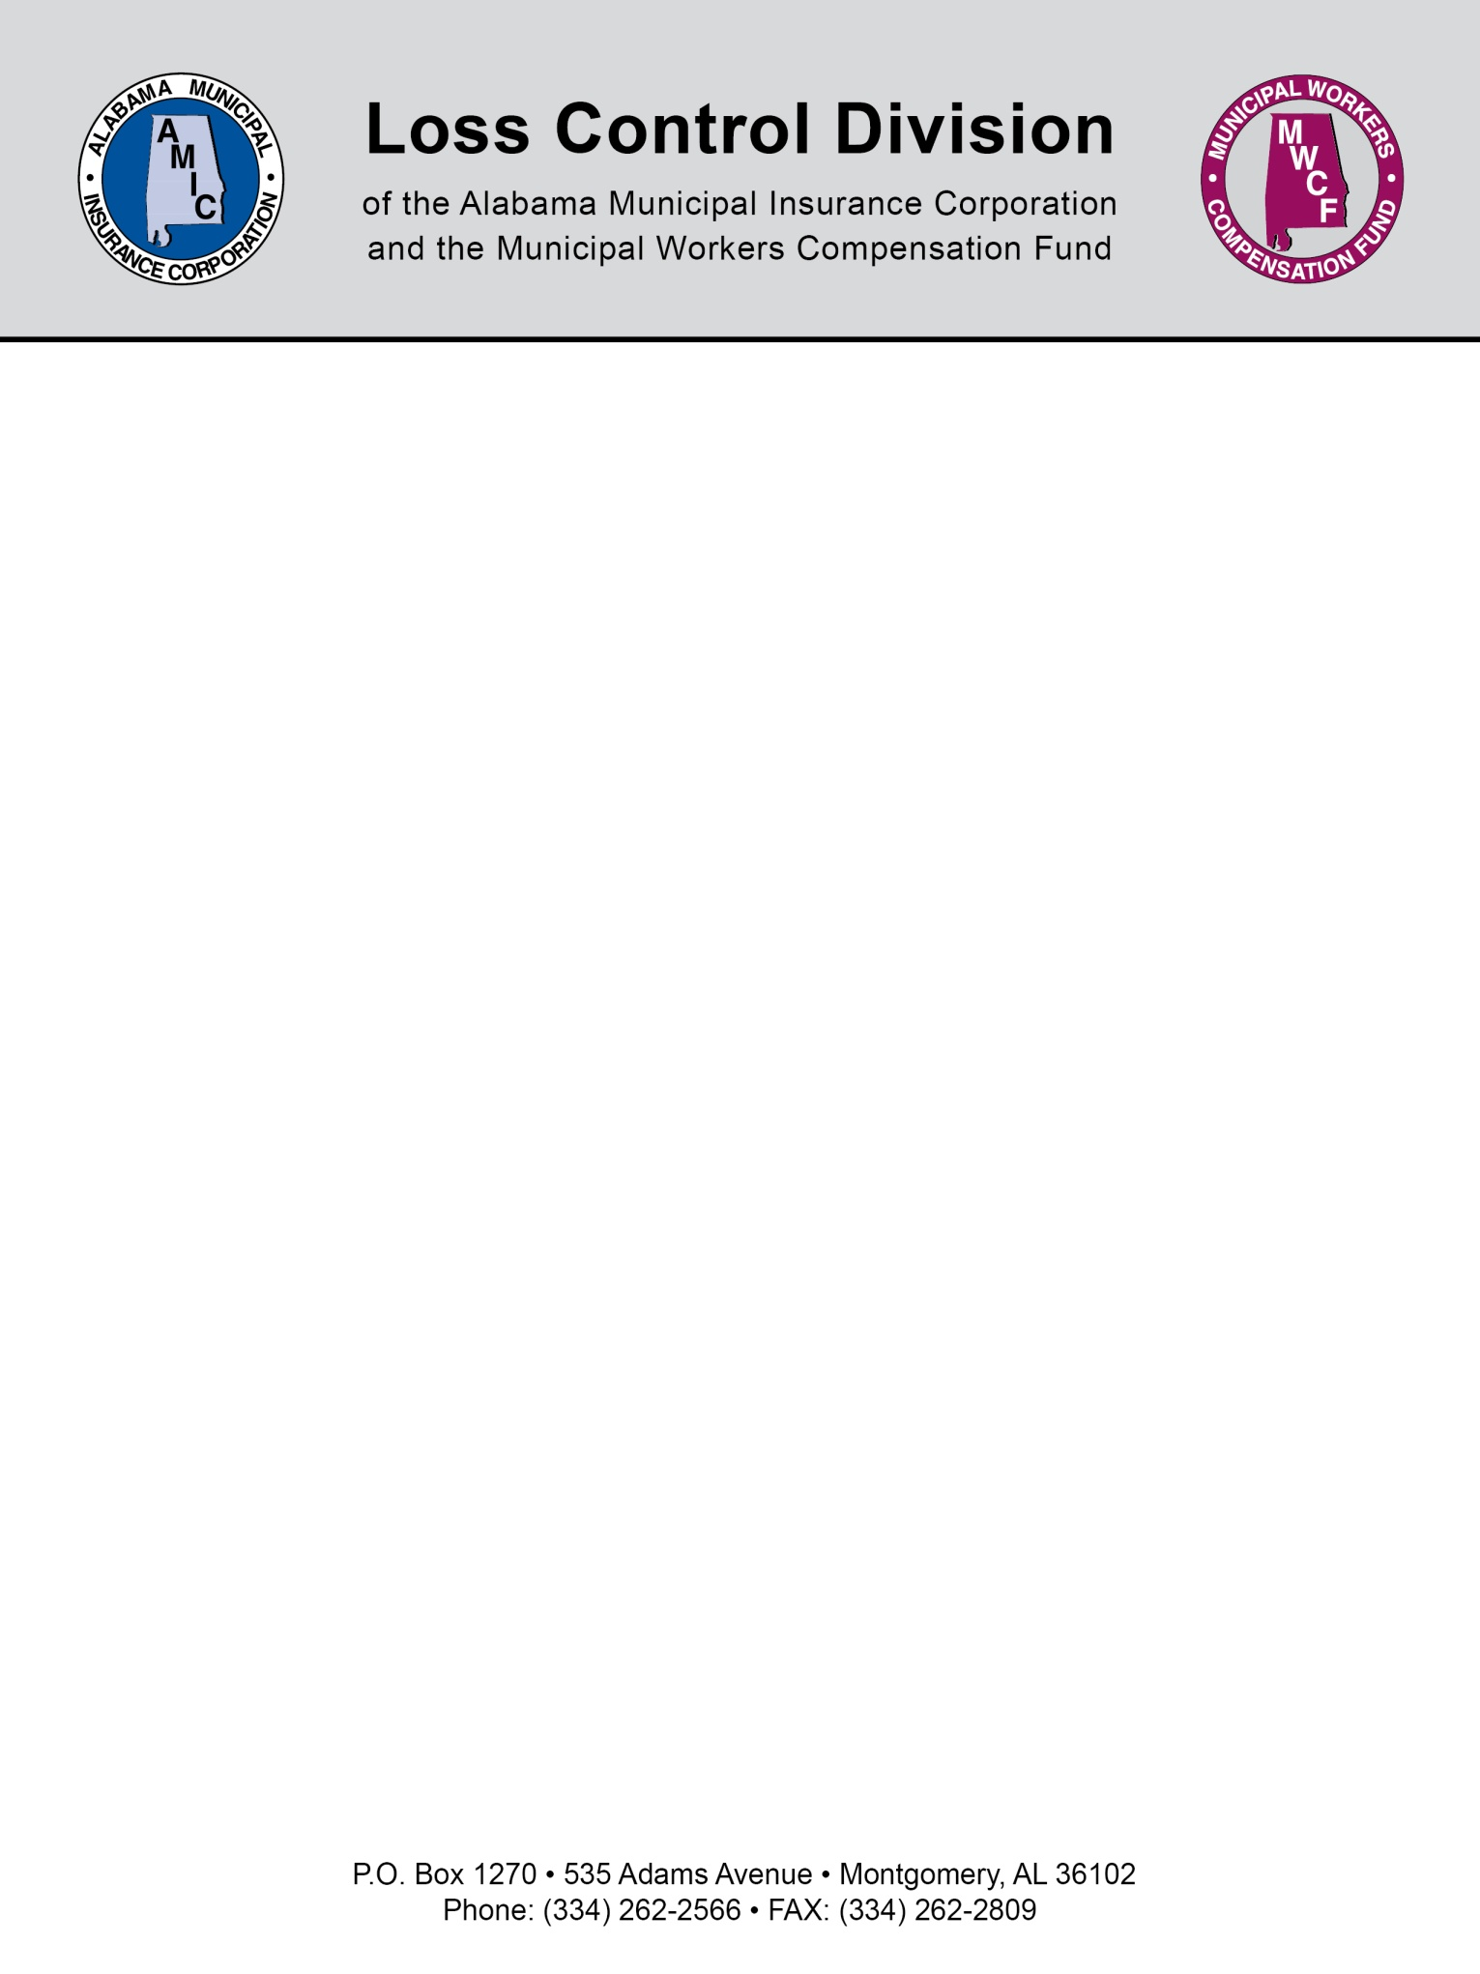

Sample Internet/Social Media
Policy and Procedures

- Policy

  - The City of Blank may provide you with Internet access to help you do your job. This policy explains our guidelines for using the Internet.

  - All Internet data that is written, sent, or received through The City of Blank’s computer systems is part of official records. That means that we can be legally required to show that information to law enforcement or other parties. Therefore, you should always make sure that the business information contained in Internet email messages and other transmissions is accurate, appropriate, ethical, and legal.

  - The equipment, services, and technology that you use to access the Internet are the property of the City of Blank. Therefore, we reserve the right to monitor how you use the Internet. We also reserve the right to find and read any data that you write, send, or receive through our online connections or is stored in our computer systems.

  - You may not write, send, read, or receive data through the Internet that contains content that could be considered discriminatory, offensive, obscene, threatening, harassing, intimidating, or disruptive to any employee or other person.

    - Examples of unacceptable content include (but are not limited to) sexual comments or images, racial slurs, gender-specific comments, or other comments or images that could reasonably offend someone on the basis of race, age, sex, religious or political beliefs, national origin, disability, sexual orientation, or any other characteristic protected by law.

  - The City of Blank does not allow the unauthorized use, installation, copying, or distribution of copyrighted, trademarked, or patented material on the Internet. As a general rule, if you did not create the material, do not own the rights to it, or have not received authorization for its use, you may not put the material on the Internet. You are also responsible for making sure that anyone who sends you material over the Internet has the appropriate distribution rights.

  - If you use the Internet in a way that violates the law or the City of Blank’s policies, you will be subject to disciplinary action, up to and including termination of employment. You may also be held personally liable for violating this policy.

    - The following are some examples of prohibited activities that violate this Internet policy:
      - Sending or posting discriminatory, harassing, or threatening messages or images
      - Using the organization's time and resources for personal gain
      - Stealing, using, or disclosing someone else's code or password without authorization
      - Copying, pirating, or downloading software and electronic files without permission
      - Sending or posting confidential material, trade secrets, or proprietary information outside of the organization
      - Violating copyright law
      - Failing to observe licensing agreements
      - Engaging in unauthorized transactions that may incur a cost to the organization or initiate unwanted Internet services and transmissions
      - Sending or posting messages or material that could damage the organization's image or reputation
      - Participating in the viewing or exchange of pornography or obscene materials
      - Sending or posting messages that defame or slander other individuals
      - Attempting to break into the computer system of another organization or person
      - Refusing to cooperate with a security investigation
      - Sending or posting chain letters, solicitations, or advertisements not related to business purposes or activities
      - Using the Internet for political causes or activities, religious activities, or any sort of gambling
      - Jeopardizing the security of the organization's electronic communications systems
      - Sending or posting messages that disparage another organization's products or services
      - Passing off personal views as representing those of the organization
      - Sending anonymous email messages
      - Engaging in any other illegal activities
      - Improper use of social media

NOTE: This document is not intended to be legal advice. It does not identify all the issues surrounding the particular topic. Public agencies are encouraged to review their procedures with an expert or an attorney who is knowledgeable about the topic. Reliance on this information is at the sole risk of the user.

Revised 5/2015

